Math 1 Name ______________________________

**6-1 – 6-3 Vocabulary, Drawings, Algebra Review** Date________

1. Use the picture below to answer the following questions.

4*x* + 1

8*x* – 13

1. What vocabulary term best describes the relationship for the angles marked above?

Term (not looking for adjacent) –

Property (circle one) – **Congruent Supplementary Complementary**

Definition – ___________________________________________________________________

___________________________________________________________________________

1. Find the value of *x*.
2. Find the measure of both angles.
3. Draw the following: 
4. If I name a line  what is another way to name it?
5. In the picture *m* || *n*. The measure of and the measure of 

2

1

*m*

4

3

*n*

6

5

8

7

1. What vocabulary term best describes the relationship for the angles mentioned above?

Term –

Property (circle one) – **Congruent Supplementary Complementary**

Definition – ___________________________________________________________________

________________________________________________________________________

1. Solve for *x*.
2. What are the measures of 

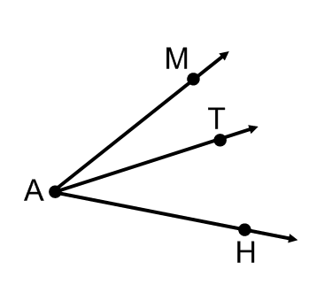

1. What is another name for (don’t say angle or acute angle)
2. What would have to be true for  to be an angle bisector for the above picture?
3. In the picture *m* || *n*. The measure of and the measure of 

2

1

*m*

4

3

*n*

6

5

8

7

1. What vocabulary term best describes the relationship for the angles marked above?

Term –

Property (circle one) – **Congruent Supplementary Complementary**

Definition – ________________________________________________________________

________________________________________________________________________

1. Solve for *x*.
2. What are the measures of 

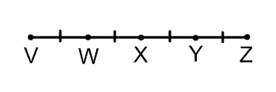

1. The distance from VX = 10 cm, what is the length of 
2. Define alternate interior angles then give an example of one pair from the figure in number 7.

______________________________________________________________________________

______________________________________________________________________________